

International Veterinary Education and Animal Welfare Symposium for Chinese Veterinary Academics

June 1, 2016

International Symposium of Veterinary Education

Preamble:
Veterinary education is of increasing global importance. The World Organisation for Animal Health (OIE) expects the modern veterinary graduate to meet a stringent set of Day-One skills. According to the OIE the quality of veterinary education is not acceptable in many countries today, and veterinary education needs to be strengthened globally. This may be achieved by sharing experiences of best practice in teaching to provide veterinary students with the knowledge, skills and confidence to tackle the issues that they will be expected to deal with in future.

Symposium Themes
A variety of topics will be covered including
- International veterinary education and the OIE
- Interactive and electronic learning
- Humane education and alternatives to animals
- Improving clinical competency
- Evidence based medicine and animal welfare

Symposium Logistics and content:

The Symposium will run over one and a half days and incorporate a variety of theoretical, innovative practical and interactive sessions involving Veterinary Academics from both the UK and China.
Symposium participants will be introduced to concepts and practice involved with the delivery of problem-based approaches for delivering effective veterinary education and developing a range of skills essential for the modern veterinary graduate.
Through a combination of workshop activities which include discussion groups, an effective range of opportunities will be made available for participants to engage with each other and share experiences of teaching within the Veterinary Curriculum
The activities will combine all aspects of the learning pyramid, and so be effective in terms of demonstrating to participants the range of teaching methodologies available to them to use with their own students.

附表1：International Veterinary Education and Animal Welfare Training Schedule
Veterinary Education 动物福利教师培训
日期  Date | 时间  Time | 课程  Course | 主讲人  Speaker | 地点  Location
June 30 | 8:30-09.00 | 欢迎词及介绍;  照集体照  Introduction and Welcome speeches; Group photo | Professor Natalie Waran (NW) | Conference hall, the library of West Campus at Jilin University
June 30 | 09.00 – 09.30 | International veterinary education –emerging trends | Dr Heather Bacon (HB)
June 30 | 09.30-10.00 | Tea Break
June 30 | 10.00 – 10.45 | The relevance of International Veterinary Nursing | Hayley Walters (HW)
June 30 | 10.45- 11.30 | Innovation in veterinary education – what skills do vets need and how should we teach them? | HB
June 30 | 12:00-14:00 | 午餐&午休Lunch Break
June 30 | 14:00-15:00 | 教学和科研中的动物使用和伦理（理论）Animal Welfare and ethics in veterinary teaching and research (theory) | NW
June 30 | 15:00-15:30 | 茶休Tea Break
June 30 | 15:30-17:00 | Innovation in teaching:  Clinical Skills and e-learning Practicals for participants | HB/HW
June 30 | 18:00 | 晚餐Dinner
July 1 | 8:30-10.00 | Clinical problem solving and case management  Presentation and discussion group sessions | HB | Conference hall, the library of West Campus at Jilin University
July 1 | 10.00 – 10.15 | Tea Break
July 1 | 10.15 -11.45 | Pain management and Animal Welfare | HW and HB
July 1 | 11.45 – 12.00 | FINAL DISCUSSION and END | ALL
July 1 | 12:00-14.00 | 午餐&午休 Lunch Break

Meet the Team

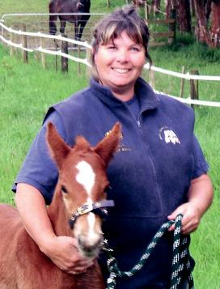
Professor Natalie Waran BSc (Hons), PhD

Professor Waran is Associate Dean (International) and also the Director of the Jeanne Marchig International Centre for Animal Welfare Education. She works with colleagues in the UK and overseas to: promote an evidence based approach to decision making about animal welfare, enhance awareness of animal welfare issues; develop the animal welfare content within veterinary education; and ensure that veterinary graduates have the skills, knowledge and confidence to advise on animal welfare. Her research interests relate to the development and recognition of indicators of negative emotions such as pain and suffering in companion animals, including horses, as well as more recently investigating methods for measuring positive emotions in animals.

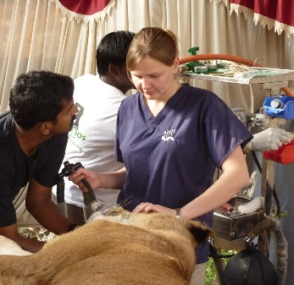
Heather Bacon BSc (Hons), BVSc, CertZooMed MRCVS
Heather is the Veterinary Welfare Education and Outreach manager at JMICAWE, and responsible for developing and coordinating some of our overseas initiatives. I organise postgraduate courses on dog and cat, and wild animal welfare, and work internationally to develop capacity in these areas. Through my role at the JMICAWE I’ve worked with NGOs, veterinary and political organisations to develop education aimed at improving animal welfare, particularly on the topics of dog population management, zoo animal, and exotic pet welfare. I’m a member of the BVA Ethics and Welfare Committee, and the Zoological Society of London ethics committee. Previously, I’ve lived in China working as the Veterinary Director at the Animals Asia Foundation, an NGO working to end the trade in bear bile across Asia.


Hayley Walters RVN

Hayley Walters qualified as a veterinary nurse through the Royal College of Veterinary Surgeons in 1999. She spent 10 years in mixed animal practice before leaving England in 2006 to work for Animals Asia in China. Her position now as a Welfare and Anaesthesia veterinary nurse divides her time between the
teaching hospital of the Royal (Dick) School of Veterinary Studies, and her animal welfare work in the UK and overseas for JMICAWE. Hayley is responsible for training veterinary students and visiting veterinarians in all aspects of animal welfare, handling, anaesthesia and pain management.

The Jeanne Marchig International Centre for Animal Welfare Education


The Jeanne Marchig International Centre for Animal Welfare Education (JMICAWE) was opened at the University of Edinburgh’s Royal (Dick) School of Veterinary Studies in May 2011. Integrated within the R(D)SVS, JMICAWE is a venture with ambitious objectives committed to improving the health and welfare of animals through education, training and research and by influencing policy at the highest level.
JMICAWE not only promotes the need for education in animal welfare science and ethics but also emphasizes the important role of veterinarians in promoting animal welfare along with their involvement in protecting public health. International concern for animal welfare continues to grow with increasing demand for measures to protect animals and improve animal quality of life. In a number of surveys, eight out of ten respondents believe that animal welfare is a key priority for a civilised society. Animals are an important part of our world, relied upon for food, used as research models, companions, working animals, for sport and in recreation.
To date, our educational and outreach activities have involved the development and delivery of a number of successful workshops provided at the invitation of collaborating Chinese and Indian Universities. The aim of the workshops has been to aid in the development of a veterinary UG curriculum that promotes the responsibility of veterinarians as ambassadors for animal health and welfare and addresses the recognized need for incorporating critical thinking and ethical analysis as well as clinical skill acquisition and a thorough understanding of infectious disease control.
Closer to home, JMICAWE is involved with both undergraduate and postgraduate students who have an interest in animal welfare, behaviour, ethics and law. We are all involved in teaching at the University and are pivotal in the developments of the MSc in Applied Animal Behaviour and Animal Welfare; International Animal Welfare, Ethics and Law; and Clinical Animal Behaviour.

Methods used for International Veterinary Education: Problem based learning

Traditionally veterinary education has tended to be content heavy. Teaching in universities has traditionally relied heavily upon lectures and tutorials, with the students' learning directed by their teachers. The purpose of this workshop is to demonstrate the way in which a problem based learning approach can be incorporated into the lecturers’ teaching tool kit –and to explore the benefits as well as the potential limitations of the approach for veterinary education in China.

PBL reverses the traditional approach to teaching and learning. It starts with individual examples or problem scenarios which stimulate student learning. In so doing, students arrive at general principles and concepts which they then generalise to other situations. Problem based learning enables contextual, cumulative, integrated, active, collaborative and reflective learning to take place, with the teacher as a facilitator of students responsible for their own learning. Problem-based learning involves the student learning how to direct and manage their own learning, developing their problem solving skills, particularly the clinical reasoning process, as well as learning important principles and key concepts. (http://www.medev.ac.uk/resources/extended_summaries_of_amee_guide/guide15_summary/)

Our programme utilises the full range of taxonomy of the cognitive domain, allowing delegates to move through each stage.

The combination of activities should provide an effective range of opportunities for delegates to immerse themselves in a problem-based-learning approach.

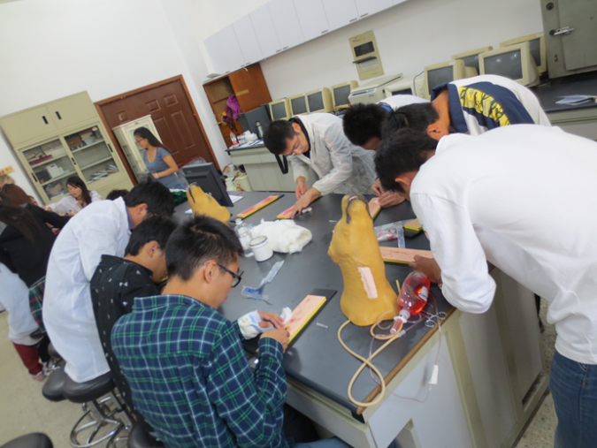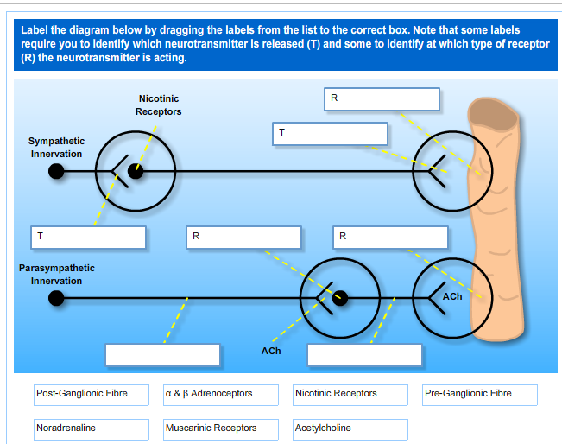

References on PBL

For a guide to PBL in Medical/veterinary education see -
http://www.newcastle.edu.au/faculty/health/teaching-learning/pbl-guide.html

Anderson, L. W., & Krathwohl, D. R. (Eds.). (2001). A taxonomy for learning, teaching and assessing: A revision of Bloom's Taxonomy of educational objectives: Complete edition, New York : Longman.

Engel C (1997) Is problem-based learning just another fashion? Changing Medical Education and Medical Practice, 6 (6), 15-7

Maudsley G (1999) Do we all mean the same thing by “problem-based learning.” A review of the concepts and a formulation of the ground rules. Academic Medicine, 74(2), 178-85

Schmidt H G (1993) Foundations of problem-based learning: some explanatory notes.
Medical Education, 27, 422-32

Animal Welfare, Ethics and Law
- Defining welfare
What do we mean by welfare?
‘Welfare’ is a difficult term to define, as it means different things to different people. The words welfare and well-being are often used as equivalent terms.
The definition of welfare often differs between the scientific and non-scientific communities. There have been several definitions of welfare proposed within the scientific literature, for example, “…the state of an individual as regards its attempts to cope with its environment” (Broom, 1986). Most animal owners attempt to care for their animals to the best of their ability, and try to make their animals ‘happy’. They therefore think they are providing them with the best quality of life possible, and that their pet is experiencing a high level of welfare. Attempts to make their pets happy often result in pet owners treating their animals like people and, in some cases, even as substitute children. Most owners would not consider that they restrict their animals in any way, despite the fact that most pets live a

completely unnatural life, particularly in terms of their social conditions. It should perhaps not be surprising that pet owners misunderstand the needs of their animals, as most children grow up reading books and watching cartoons where animals show many human characteristics, such as talking, living in houses and showing human emotions. The Farm Animal Welfare Council (FAWC), an independent advisory body, developed the Five Freedoms in relation to welfare. These state that animals should have
- Freedom from hunger and thirst – by ready access to fresh water and a diet to maintain full health and vigour
- Freedom from discomfort – by providing an appropriate environment, including shelter and a comfortable resting area
- Freedom from pain, injury and disease – by prevention or rapid diagnosis and treatment
- Freedom to express normal behaviour – by providing sufficient space, proper facilities and company of the animal’s own kind
- Freedom from fear and distress – by ensuring conditions and treatment which avoid mental suffering
These freedoms take into account the physical and psychological well-being of the animal. The list of freedoms is not definitive and they are to some extent incompatible, however, they provide a useful framework, and categorisation, of possible welfare concerns. Some of the incompatibility is due to the fact that the freedoms consider the health of animals and their feelings, whilst also taking into account their natural behaviour. There are differences in opinion over which of these approaches is most appropriate. For example, a housing system may provide an animal with all it needs for good physical health, such as food, water, warmth and shelter, therefore in terms of its physical health, the animal may be experiencing a high level of welfare. However, the same housing system may be very restrictive in terms of the performance of natural behaviour, and in that respect, the animal may be experiencing poor welfare. Although there is disagreement over which approach is most appropriate, there is much overlap between the three approaches. This disagreement between different views of welfare is unavoidable, and in fact there is also disagreement over what is required for high levels of welfare in humans.
It is important to distinguish between welfare and cruelty. Cruelty is considered to be negative and extreme, such as starvation or physical abuse, whereas the state of welfare can vary along a scale from good to bad. Current legislation in the UK focuses on cruelty, and therefore does not promote higher welfare standards.
Welfare concerns of animals under human care

Animals in captivity experience many factors that might affect their welfare. These include the social conditions, dietary factors, keeper relationship, visitor behaviour, daily husbandry and behavioural restriction. As a result of differences between species and their behaviour, there are specific welfare concerns for different animals. For example:
Dogs – One of the main welfare concerns for pet dogs is the inappropriate social structure. Dogs are pack animals, yet it is extremely common for pet dogs to be kept without other dogs. Dogs kept singly may become more attached to their owners than dogs kept with more owners, and in these circumstances the dogs may develop separation related problems when they are left on their own.
There are also welfare concerns over the way animals are trained. Many people who train animals do use appropriate reward-based methods, however, often a lack of true understanding of learning theory may cause these techniques to be used ineffectively. This can lead to confusion and the animals being unable to make the correct association between what is being asked of them and the reward. Breakdowns in training may lead to aversive and even inhumane techniques being used, particularly when owners are training an animal for competition and are under pressure.
How can we improve the welfare of animals?
As mentioned above, cruelty to animals tends to be extreme, and it is obvious to most people when an animal has been the victim of cruelty, and what should be done to prevent further cruelty. However, factors that negatively affect the welfare of an animal may be less obvious to many people.
In order to improve the welfare of animals, we must be able to assess welfare. Unless we have some way of assessing welfare, we are unable to determine if the welfare of the animals has altered, for example, after a change in the environment. In order to assess welfare, we must have knowledge of the behaviour of that species, its behavioural needs and the possible effects the environment can have on behaviour.
Assessing welfare
In trying to assess welfare, what we are really trying to do is to determine how animals feel about what we do to them. We cannot use subjective approaches, therefore we require objective approaches to the assessment of welfare.
- Assessing Animal Welfare
We can use our knowledge of animal physiology and both normal and abnormal behaviour as complementary approaches in the assessment of the welfare of an animal in its captive environment. We can also employ experimental techniques to determine the preferences of an animal, or how aversive it finds a procedure. These experimental techniques allow us to

‘ask’ the animals how they feel about their environment. We can then modify the captive environment accordingly, to improve the welfare of the animal.

References and further reading on Animal Welfare:

Appleby, M.C., 1999. What Should We Do About Animal Welfare? Blackwell Science Ltd, UK.

Broom, D.M., 1986. Indicators of poor welfare. British Veterinary Journal, 142: 524-526.

WSPA CONCEPTS IN ANIMAL WELFARE DVD

Further Information and Teaching Resources:

Welfare and Farm Animals:

http://www.ciwf.org.uk/resources/education/default.aspx

http://www.rspca.org.uk/sciencegroup/farmanimals/standards

http://www.hsi.org/campaigns/support_farm_animals/

General Welfare:

http://www.wspa-international.org/wspaswork/education/concepts-animal-welfare-modules.aspx

https://www.avma.org/public/animalwelfare/pages/default.aspx

https://www.avma.org/KB/Resources/Reference/AnimalWelfare/Pages/default.aspx

NOTES:

